How to use RS485 software
I. Connect RS485 sensors to Computer
Connect the sensor with RS485 to USB converter to user’s computer.
II. Install “Drive” in user computer.
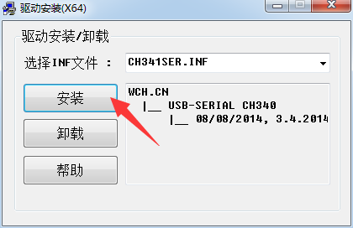
By Click “Install” (安装).

Remarks: After installing the drive, it will show that the installation is successful (“安装成功”). If the installation is unsuccessful, it will show that the pre-installation is successful (“预安装成功”).

III. Operation Steps on RS485 software
1. Click and open the software
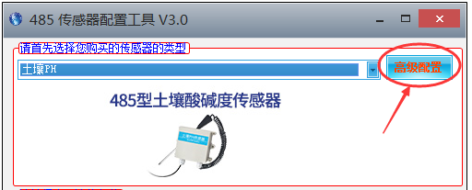
2. Click “高级设置” at right top of the page and change language to English

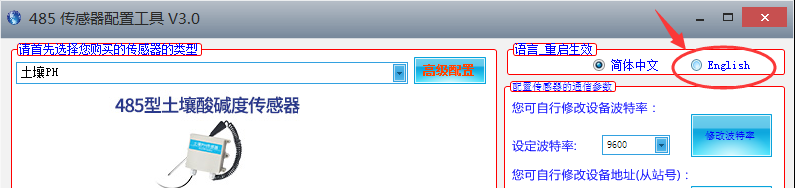

3. Right click on the computer to open the “device manager”,
Select the port at the port “COM #”
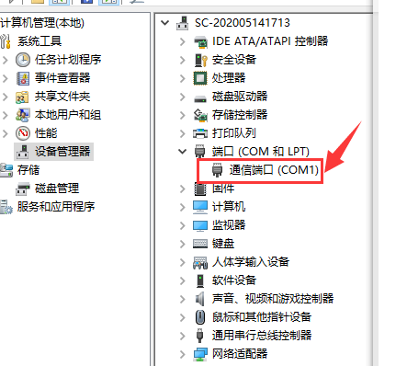
4. Per below Picture: Put the “COM #” into A, and click B to refresh, then click C.
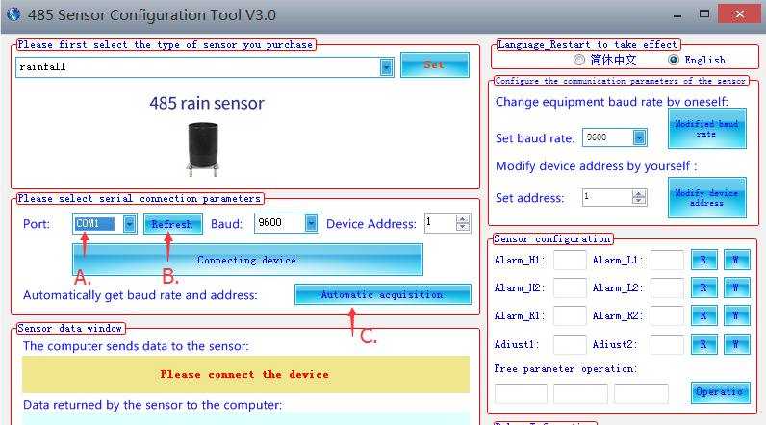
5. Per below picture: Select Product Name in the list below by A to B and click C to set, and then click “connecting device”.
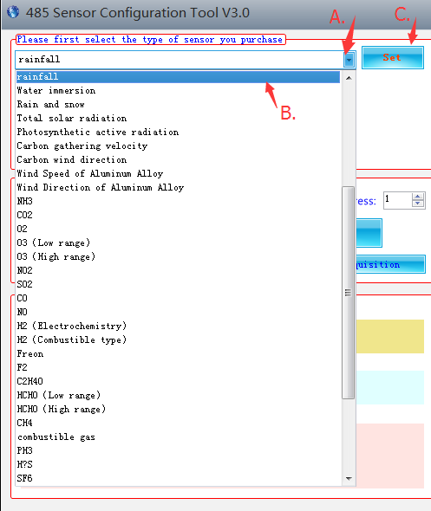
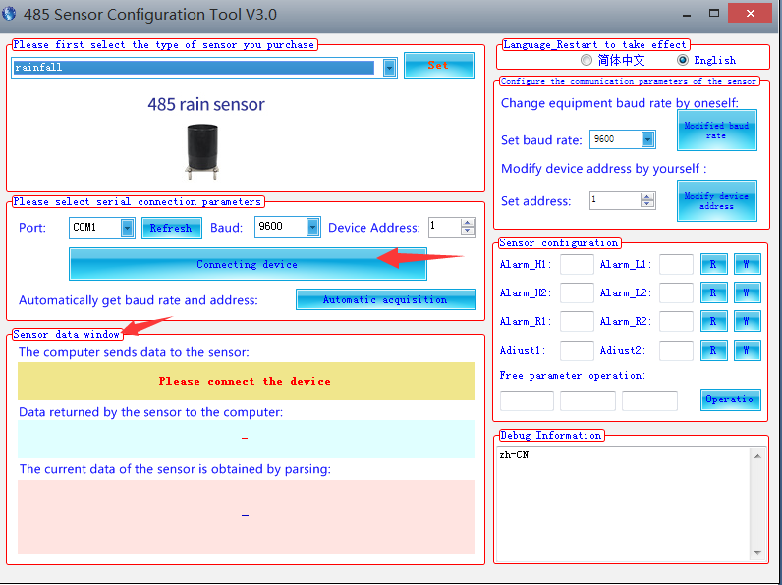
6. Then if the sensor is well connected, user can see data status on “Sensor data window”

